According to Intelli, the Norway diagnostic imaging devices market was valued at USD 272.89 million in 2024 and is expected to reach USD 383.03 million by 2032, growing at a CAGR of 5.23% during the forecast period of 2024 to 2032.

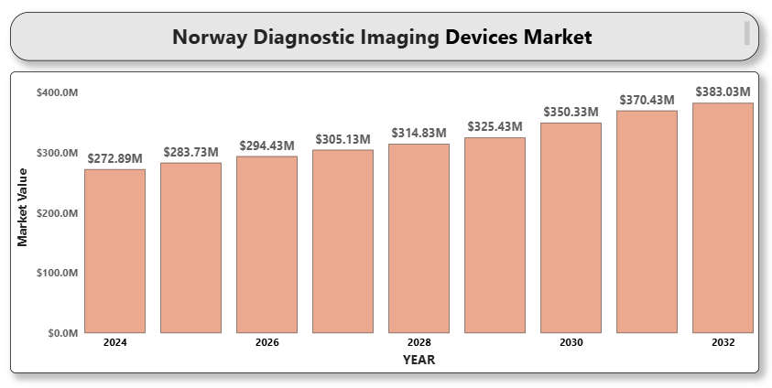

The market is driven by Norway’s technologically advanced healthcare infrastructure, high healthcare expenditure, and increasing demand for early and accurate diagnosis. The aging population, growing incidence of chronic diseases, and rising awareness about preventive healthcare contribute to the growing adoption of diagnostic imaging equipment across the country.

**Norway Diagnostic Imaging Devices Market Definition**

Diagnostic imaging devices are non-invasive tools used to visualize internal organs and tissues for diagnostic and therapeutic purposes. These include X-ray, computed tomography (CT), magnetic resonance imaging (MRI), ultrasound, and nuclear imaging technologies. The market encompasses devices used in hospitals, diagnostic centers, and other healthcare settings.

**Norway Diagnostic Imaging Devices Market Overview**

The Norwegian market is highly developed and characterized by quick adoption of cutting-edge medical imaging technology. Government initiatives to upgrade healthcare infrastructure and digitize medical records have improved the integration of imaging devices with electronic health systems. AI-enabled diagnostics and hybrid imaging technologies are gaining traction.

The COVID-19 pandemic initially disrupted elective imaging procedures but also accelerated investments in radiology infrastructure. Continued emphasis on remote diagnostics, teleradiology, and efficient workflows is reshaping the imaging landscape in Norway.

**Norway Diagnostic Imaging Devices Market Segmentation Analysis**

**Market Segmentation by Product Type:**

* A close-up of hands holding a tablet and a pen

  Description automatically generatedX-ray Imaging Systems
  + Digital X-ray
  + Analog X-ray
* Ultrasound Systems
  + 2D Ultrasound
  + 3D & 4D Ultrasound
  + Doppler Imaging
* Computed Tomography (CT) Scanners
* Magnetic Resonance Imaging (MRI) Systems
* Nuclear Imaging Equipment
  + PET
  + SPECT
* Mammography Systems
* Others

CT and MRI systems lead the market due to rising demand for advanced diagnostic imaging and precision medicine. Ultrasound remains widely used for real-time imaging and cost-effectiveness.

**Market Segmentation by Application:**

* Cardiology
* Oncology
* Neurology
* Orthopedics
* Gynecology
* Others

Oncology dominates due to the increasing incidence of cancer and the importance of early detection. Cardiology and neurology are also key segments, supported by high demand for accurate diagnostic capabilities.

**Market Segmentation by End User:**

* A close-up of hands holding a tablet and a pen

  Description automatically generatedHospitals
* Diagnostic Imaging Centers
* Ambulatory Surgical Centers
* Clinics

Hospitals remain the primary users due to comprehensive diagnostic setups. However, diagnostic imaging centers are rapidly growing, especially in urban areas, due to convenience and cost-efficiency.

**Market Segmentation by Region:**

* Eastern Norway
* Western Norway
* Northern Norway
* Central Norway

Eastern Norway holds the largest market share, led by cities like Oslo with advanced healthcare systems and high patient footfall. Government investment is helping expand access to imaging devices in remote northern regions.

**Key Players**

Leading companies operating in the Norway diagnostic imaging devices market include Siemens Healthineers, GE HealthCare Technologies Inc., Koninklijke Philips N.V., Canon Medical Systems Corporation, Fujifilm Holdings Corporation, Hitachi Ltd., Esaote SpA, Hologic Inc., Samsung Medison Co., Ltd., and Shimadzu Corporation.

**Key Developments**

* In March 2024, GE HealthCare launched its next-generation AI-integrated MRI system in the Nordic region.
* In Jan 2024, HoloCare a norway based firm has created software that produces interactive 3D holograms of a specific patient's organ, enabling surgeons to accurately plan and tailor surgeries to the patient's individual anatomy.
* A close-up of hands holding a tablet and a pen

  Description automatically generatedIn 2024, Acoustic cluster therapy (ACT®) started a clinical trial targeting pancreatic cancer, which poses medical challenges due to its aggressive nature.

**Market Attractiveness**

Norway offers a highly attractive market environment due to robust public funding, advanced technology adoption, and a proactive regulatory framework. Strong telehealth infrastructure and integration with AI-based imaging solutions enhance the future growth outlook.

**Porter's Five Forces**

* Threat of New Entrants: Low to Moderate. High capital investment and regulatory hurdles deter new players.
* Bargaining Power of Suppliers: Moderate. Established component suppliers dominate, though alternatives exist.
* Bargaining Power of Buyers: High. Hospitals and procurement agencies negotiate based on performance and pricing.
* Threat of Substitutes: Low. Imaging remains critical for diagnosis, though some overlap with lab diagnostics exists.
* Industry Rivalry: High. Strong competition among top global players drives innovation and price competitiveness.

**TABLE OF CONTENTS**

1. **INTRODUCTION OF NORWAY DIAGNOSTIC IMAGING DEVICES MARKET**

1.1 Overview of the Market

1.2 Scope of Report

1.3 Assumptions

1. **EXECUTIVE SUMMARY**
2. **RESEARCH METHODOLOGY**

3.1 Data Mining

3.2 Validation

3.3 Primary Interviews

3.4 List of Data Sources

1. **NORWAY DIAGNOSTIC IMAGING DEVICES MARKET OUTLOOK**

4.1 Overview

4.2 Market Dynamics

4.2.1 Drivers

4.2.2 Restraints

4.2.3 Opportunities

4.2.4 Trends

4.3 Porter's Five Force Model

4.4 Value Chain Analysis

1. **NORWAY DIAGNOSTIC IMAGING DEVICES MARKET, BY PRODUCT TYPE**

5.1 X-ray Imaging Systems

5.2 Ultrasound Systems

5.3 Magnetic Resonance Imaging (MRI)

5.4 Computed Tomography (CT)

5.5 Nuclear Imaging Systems

1. **NORWAY DIAGNOSTIC IMAGING DEVICES MARKET, BY APPLICATION**

6.1 Cardiology

6.2 Oncology

6.3 Neurology

6.4 Orthopedics

6.5 Gastroenterology

6.6 Others

1. **NORWAY DIAGNOSTIC IMAGING DEVICES MARKET, BY END USER**

7.1 Hospitals

7.2 Diagnostic Imaging Centers

7.3 Ambulatory Surgical Centers

7.4 Clinics

1. **A close-up of hands holding a tablet and a pen

   Description automatically generatedNORWAY DIAGNOSTIC IMAGING DEVICES MARKET, BY REGION**

8.1 Eastern Norway

8.2 Western Norway

8.3 Northern Norway

8.4 Southern Norway

1. **NORWAY DIAGNOSTIC IMAGING DEVICES MARKET COMPETITIVE** **LANDSCAPE**

9.1 Overview

9.2 Company Market Ranking

9.3 Key Development Strategies

1. **COMPANY PROFILES**

**10.1 Siemens Healthineers**

10.1.1 Overview

10.1.2 Financial Performance

10.1.3 Product Outlook

10.1.4 Key Developments

**10.2 GE HealthCare Technologies Inc.**

10.2.1 Overview

10.2.2 Financial Performance

10.2.3 Product Outlook

10.2.4 Key Developments

**10.3 Philips Healthcare**

10.3.1 Overview

10.3.2 Financial Performance

10.3.3 Product Outlook

10.3.4 Key Developments

**10.4 Canon Medical Systems Corporation**

10.4.1 Overview

10.4.2 Financial Performance

10.4.3 Product Outlook

10.4.4 Key Developments

**10.5 Fujifilm Holdings Corporation**

10.5.1 Overview

10.5.2 Financial Performance

10.5.3 Product Outlook

10.5.4 Key Developments

**10.6 Hologic Inc.**

10.6.1 Overview

10.6.2 Financial Performance

10.6.3 Product Outlook

10.6.4 Key Developments

**10.7 Mindray Medical International Ltd.**

10.7.1 Overview

10.7.2 Financial Performance

10.7.3 Product Outlook

10.7.4 Key Developments

**10.8 Esaote SpA**

10.8.1 Overview

10.8.2 Financial Performance

10.8.3 Product Outlook

10.8.4 Key Developments

**10.9 Samsung Medison Co., Ltd.**

10.9.1 Overview

10.9.2 Financial Performance

10.9.3 Product Outlook

10.9.4 Key Developments

1. **KEY DEVELOPMENTS**

11.1 Product Launches/Developments

11.2 Mergers and Acquisitions

11.3 Business Expansions

11.4 Partnerships and Collaborations

1. **APPENDIX**

12.1 Related Research